This is the template for the Abstract to be submitted to GISR2014

Name Surname¹ of the presenting Author, Name Surname² of second Author, Name Surname third Author³....

¹ Affiliation of presenting Author with postal address and e-mail
² Affiliation of the second Author with postal address
³ Affiliation of the third Author with postal address

Please use this template for the abstract of the papers to be presented at GISR 2014. The abstract has to be written in English, the official language of the Meeting.
The maximum length of the abstract is one page, A4 format. The character is Arial, bold 14 pt for the title, bold 10 pt for the authors’ names, italic 9 pt for the affiliation, normal 10 pt for the body of the abstract, and normal 9 pt for the bibliography. Images can be inserted within the text or at the end, with captions in Arial italic, 9 pt. Color figures will be reproduced in Gray. Please do not insert Tables.
The abstract has to be saved as Surname_oral.docx or Surname_poster.docx (where Surname is the surname of the presenting author), and sent to gisr2014@unipr.it, with abstract_gisr14 as Subject. Only abstracts of registered participants will be considered for acceptance, so please register before submitting the abstract.
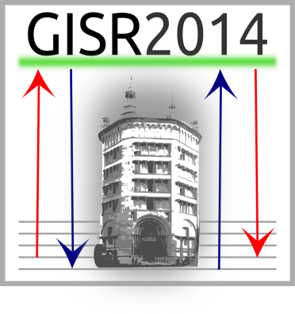
Text Text Text Text Text Text Text Text Text Text Text Text Text Text Text Text Text Text Text Text Text Text Text Text Text Text Text Text Text Text Text Text Text Text Text Text Text Text Text Text Text Text Text Text Text Text Text Text Text Text Text Text Text Text Text Text Text Text Text Text Text Text Text Text Text Text Text Text Text Text Text Text Text Text Text Text Text Text Text Text Text Text Text Text Text Text Text Text Text Text Text
Text Text Text Text Text Text Text Text Text Text Text Text Text Text TextText Text Text Text Text Text Text Text Text Text Text Text Text Text Text Text Text Text Text Text Text Text Text Text Text Text Text Text Text Text Text Text Text Text Text Text Text Text Text Text Text Text Text Text Text Text Text Text Text Text Text Text Text Text Text Text Text Text Text Text TextText Text Text Text Text Text Text Text Text Text Text Text Text Text Text Text Text Text Text Text Text Text Text Text Text Text Text Text Text Text Text Text Text Text Text Text Text Text Text Text Text Text Text Text Text Text Text Text Text Text Text Text TextText Text Text Text Text Text Text Text Text Text Text Text Text Text Text Text Text Text Text Text Text Text Text Text Text Text Text Text Text Text Text Text Text Text Text Text Text Text Text Text Text Text Text Text Text Text Text Text Text Text Text Text TextText Text Text Text Text Text Text Text Text Text Text Text Text Text Text Text Text Text Text Text Text Text Text Text Text Text Text Text Text Text Text Text Text Text Text Text Text Text Text Text Text Text Text Text Text Text Text Text Text Text Text Text Text
Fig. 1 - This is an example of figure. Color figures will be printed in Gray

References
- Surname, B. Surname, J. Raman Spectrosc. 44, 7 (2013).
- Surname, D. Surname, Book Title, Editor, Location (2013).

